**Lab Task 7**

**My Application: Loop Statement**

**Objective:**

* Using looping statement

1. Compile and run this program using LiveCode. What will be displayed? (Loops/For)

put 0 into n  
repeat for 5 times   
 add 1 to n  
 repeat for n times  
 put "*" after string

put string into field “display”   
 end repeat

put cr after string  
end repeat

1. Timer Application
   1. Design the application as below:

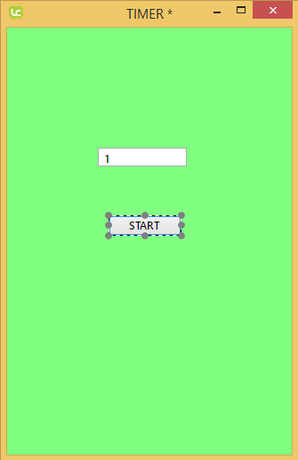

* 1. Then, write the following code in button start:

|  |
| --- |
| **on** mouseUp  **put** 10 into count  **repeat** while count > 0  **put** count into field "timer"  **wait** 1 second  **add** -1 to count  **end** **repeat**  **end** mouseUp |

**Tutorial Question:**

Edit task in question 2 by adding Stop and Resume button. Stop button will stop the timer and it will continue running if user click Resume button.